
INTERNET NETWORK ROUTING OPTIMIZER
Shortest Path Routing using Dijkstra's Algorithm
A Python Desktop Application with Graph Visualization
Design and Analysis of Algorithms (DAA)
Final Project Report
Submitted by
KAVITA KUMARI
(UID: 26MCI10091)
Master of Computer Applications
IN
Artificial Intelligence and Machine Learning (MCA AI & ML)
UNIVERSITY INSTITUTE OF COMPUTING (UIC)

CHANDIGARH UNIVERSITY

Under the Supervision of
[Ms.Kawaljit Kaur]

OCTOBER 2026
CERTIFICATE
This is to certify that the project report entitled "Internet Network Routing Optimizer" has been prepared by Kavita Kumari (UID: 26MCI10091) as part of the academic work for the Master of Computer Applications (AI & ML) programme at the University Institute of Computing, Chandigarh University, for the subject Design and Analysis of Algorithms. The project demonstrates the application of Dijkstra's shortest path algorithm to find minimum-latency routes in a computer network, implemented in Python with a graphical interface and a graph visualization.

Supervisor's Signature: ______________________________
Name: ______________________________
Date: ______________________________
DECLARATION
I declare that this report describes the Internet Network Routing Optimizer project prepared for academic learning. The program, its screens, the sample network and the results described here are based on the implementation developed in Python using Dijkstra's algorithm, NetworkX and Matplotlib. Institutional details and signatures should be completed before submission.

Student Signature: ________________
Student Name: Kavita Kumari
ACKNOWLEDGEMENT
I would like to thank my faculty, my supervisor and the department for the opportunity to learn algorithm design through this project. I also acknowledge the Python community and the official documentation of NetworkX, Matplotlib and Tkinter, which were the main resources used while building and testing the application. The project helped me understand graphs, greedy algorithms, priority queues, time and space complexity, file handling with JSON and graphical user interface design.
ABSTRACT
The Internet Network Routing Optimizer is a Python application that finds the minimum-latency route between two routers of a computer network. The network is modelled as a weighted graph in which routers are nodes and the connections between them are edges whose weights represent latency. The shortest route is calculated using Dijkstra's algorithm with a priority queue (min-heap), which gives a time complexity of O((V + E) log V).
The network details and a list of routing requests are stored in a JSON file (data.json), so the topology can be changed without editing the program. The project has a command-line mode, in which the user selects a routing request and receives the route and the total latency, and a graphical mode, in which the user selects the source and destination routers from drop-down lists and presses the Find Shortest Path button. In both modes the network is drawn as a graph with the selected route highlighted in red, the source router in green and the destination router in orange.
For the sample network of eight routers and fourteen connections, the shortest route from R3 to R6 is R3 -> R2 -> R4 -> R6 with a total latency of 9 units, and the shortest route from R1 to R6 is R1 -> R3 -> R2 -> R4 -> R6 with a total latency of 11 units. The project is an academic prototype and is not connected to a real network or to live latency measurements.
TABLE OF CONTENTS
Chapter | Title
1 | Introduction
2 | Problem Statement and Objectives
3 | Scope, Limitations and Feasibility
4 | Requirements and Technologies
5 | Algorithm: Dijkstra's Shortest Path
6 | System Design
7 | Data Structures and Modules
8 | Implementation
9 | User Interface and Screenshots
10 | Testing and Results
11 | Complexity Analysis
12 | Conclusion and Future Enhancements
13 | Viva Questions and Answers
 | References
LIST OF FIGURES
Figure | Title
Fig. 5.1 | Sample network graph and shortest path from R1 to R7
Fig. 6.1 | Flowchart of the project
Fig. 9.1 | Graphical interface of the Routing Optimizer (R1 to R6)
Fig. 9.2 | Command-line mode: selecting routing request 3
Fig. 9.3 | Visualization of the route R3 to R6
1. INTRODUCTION
1.1 Background
Every message sent over the Internet is divided into small packets, and each packet travels from the sender to the receiver through a series of routers. A router is a device that receives a packet and forwards it to the next device on the way to the destination. Between two routers there may be many possible paths, and each path takes a different amount of time. The time taken by a packet to cross a link is called latency, and it is usually measured in milliseconds.
Choosing a path with a low total latency makes web pages load faster, video calls smoother and file transfers quicker. Routing algorithms are therefore one of the most important parts of computer networks. Many of them are based on shortest path algorithms from graph theory, and the best known of these is Dijkstra's algorithm.
1.2 About Dijkstra's Algorithm
Dijkstra's algorithm is an algorithm for finding the shortest paths between nodes in a graph, which may represent, for example, road networks or computer networks. The original variant found the shortest path between two nodes, but a more common variant fixes a single node as the "source" node and finds the shortest paths from the source to all other nodes in the graph, producing a shortest-path tree.
- It can be applied to either directed or undirected graphs.
- It works on graphs with non-negative edge weights.
- It is applied on a connected graph, so that every router can be reached.
- It follows the greedy approach: the router with the smallest known distance is always finalised first.
1.3 About the Project
The Internet Network Routing Optimizer is a Python application that applies Dijkstra's algorithm to a small computer network. The network contains eight routers (R1 to R8) and fourteen connections. The user chooses a source router and a destination router, and the program calculates the route with the minimum total latency, prints the route and its latency, and draws the network with the route highlighted.
1.4 Motivation
The main aim of the project is to design an Internet Network Routing Optimizer using an algorithm from the DAA syllabus. The algorithm should find the minimum-latency route between a source router and a destination router so that data packets reach the destination as fast as possible. The project connects theory with practice: the same algorithm that is studied with pseudo code and examples in class is implemented, tested and visualised on a realistic problem.
1.5 Organisation of the Report
Chapter 2 states the problem and objectives. Chapter 3 describes scope, limitations and feasibility. Chapter 4 lists the requirements and technologies. Chapter 5 explains the algorithm with pseudo code and a worked example. Chapter 6 presents the system design. Chapter 7 describes the data structures and modules. Chapter 8 explains the implementation. Chapter 9 shows the user interface with screenshots. Chapter 10 covers testing and results, Chapter 11 analyses the complexity, Chapter 12 gives the conclusion and future work, and Chapter 13 provides viva questions and answers.
2. PROBLEM STATEMENT AND OBJECTIVES
2.1 Problem Statement
In a network with many routers and links of different latency, the path with the fewest links is not always the fastest path. A route that looks short can contain a slow link, while a longer route made of fast links may deliver the packet earlier. Checking every possible path by hand is slow and error-prone, and the number of paths grows quickly as the network becomes larger. A systematic method is needed to find the minimum-latency route between any two routers.
2.2 Objectives
- Represent a computer network as a weighted graph with routers as nodes and latency as edge weights.
- Store the routers, connections and routing requests in a JSON file so that the network can be changed easily.
- Implement Dijkstra's algorithm with a priority queue to find the minimum-latency route.
- Display the source, destination, shortest route and total latency to the user.
- Draw the network graph and highlight the selected route in a different colour.
- Provide a graphical interface in which the user can select the source and destination routers.
- Analyse the time and space complexity of the solution.
2.3 Proposed Solution
The proposed solution models the network as a graph and runs Dijkstra's algorithm from the source router. The algorithm keeps a distance value for every router, starting with infinity for all routers and zero for the source. It repeatedly picks the router with the smallest distance, finalises it, and updates the distances of its neighbours. A previous-router array records how each router was reached, and the final route is rebuilt from the destination back to the source using this array.
3. SCOPE, LIMITATIONS AND FEASIBILITY
3.1 Scope
- The sample network has eight routers and fourteen bidirectional connections with latency values.
- The program finds the minimum-latency route between any two selected routers.
- A list of predefined routing requests (for example R1 to R8 or R3 to R6) can be chosen by number.
- A graphical interface and a Matplotlib visualization display the network and the result.
- The network can be extended by adding routers and connections in the JSON file.
3.2 Limitations
- The latency values are fixed sample data; the program does not measure real network delay.
- Dijkstra's algorithm cannot handle negative edge weights, which do not occur in latency.
- The program finds only one shortest route when several routes have the same total latency.
- It is a desktop prototype and does not control real routers or forward real packets.
- Very large networks would need a more optimised layout and faster drawing.
3.3 Feasibility Study
Type | Assessment
Technical | Python, NetworkX, Matplotlib and Tkinter are free, widely available and sufficient for the graph, algorithm and interface.
Economic | No paid software or hardware is required. The project runs on an ordinary personal computer.
Operational | The user only selects two routers and presses a button, so the application is easy to use.
Schedule | The project is small enough to be designed, coded and tested within one academic semester.
4. REQUIREMENTS AND TECHNOLOGIES
4.1 Hardware Requirements
Component | Minimum Requirement
Processor | Dual-core processor, 1.5 GHz or higher
Memory (RAM) | 2 GB or more
Storage | 100 MB free disk space for Python, libraries and project files
Display | 1366 x 768 resolution or higher so that the graph is clearly visible
Input devices | Keyboard and mouse
4.2 Software Requirements
Component | Requirement
Operating system | Windows 10 or 11 (also works on Linux and macOS with Python)
Language | Python 3.x (Python 3.13, 64-bit, was used during development)
Graph library | NetworkX, used for building the graph and calculating node positions
Plotting library | Matplotlib, used for drawing the network and highlighting the route
GUI library | Tkinter (included with standard Python)
Editor | Visual Studio Code with the Python extension
Version control | Git and GitHub for storing the source code
4.3 Tools and Technologies Used
Technology | Use
Python 3 | Main programming language used for the algorithm, data loading and user interaction.
JSON | Stores routers, connections with latency, and the list of routing requests in data.json.
heapq (priority queue) | Gives the router with the minimum distance in logarithmic time.
NetworkX | Builds the graph object and computes a layout for drawing.
Matplotlib | Draws nodes, edges, labels and the highlighted route.
Tkinter | Provides the window, drop-down lists and buttons of the graphical interface.
4.4 Why Python?
Python was chosen because its syntax is simple and close to pseudo code, which makes it easy to translate an algorithm from the textbook into a working program. It has a rich set of libraries for graphs and plotting, built-in data structures such as lists, dictionaries and heaps, and a standard library for reading JSON files. These features let the project concentrate on the algorithm instead of low-level details.
5. ALGORITHM: DIJKSTRA'S SHORTEST PATH
5.1 Idea of the Algorithm
Dijkstra's algorithm is a greedy algorithm. It maintains, for each router, the best distance found so far from the source. At every step it selects the unfinalised router with the smallest distance. Because all latencies are non-negative, no later route can make that distance smaller, so the router can be finalised safely. The algorithm then checks whether going through this router gives a shorter distance to any of its neighbours, a step called relaxation.
5.2 Pseudo Code
Initialize the distance of each router to infinity
Initialize the distance of the source router to 0
Insert the source router into a priority queue
While the priority queue is not empty
Extract the router u with the minimum distance
For each router v which is adjacent to u
v's distance = min(v's old distance, u's distance + latency(u, v))
If v's distance is updated:
set previous[v] = u and add v to the queue
Reconstruct the shortest path using previous[]

5.3 Step-by-Step Solution
Find the shortest path between a source router u and a destination router v using Dijkstra's algorithm:
1) Create a set sptSet (shortest path tree set) that keeps track of routers included in the shortest path tree, i.e. whose minimum distance from the source is calculated and finalised. Initially, this set is empty.
2) Assign a distance value to all routers in the input graph. Initialise all distance values as INFINITE. Assign the distance value 0 to the source router so that it is picked first.
3) While sptSet does not include all routers:
a) Pick a router u which is not in sptSet and has the minimum distance value (using a priority queue / min-heap).
b) Include u in sptSet.
c) Update the distance value of all adjacent routers of u. For every adjacent router v, if the sum of the distance value of u (from the source) and the latency of the edge u-v is less than the distance value of v, update the distance value of v and set previous[v] = u.
4) Reconstruct the path from the destination back to the source using previous[] and display it with the total latency.
5.4 Worked Example
For example, consider the source router R1 and the destination router R7. The shortest path from R1 to R7 can be calculated as shown below, with the shortest path highlighted in red.
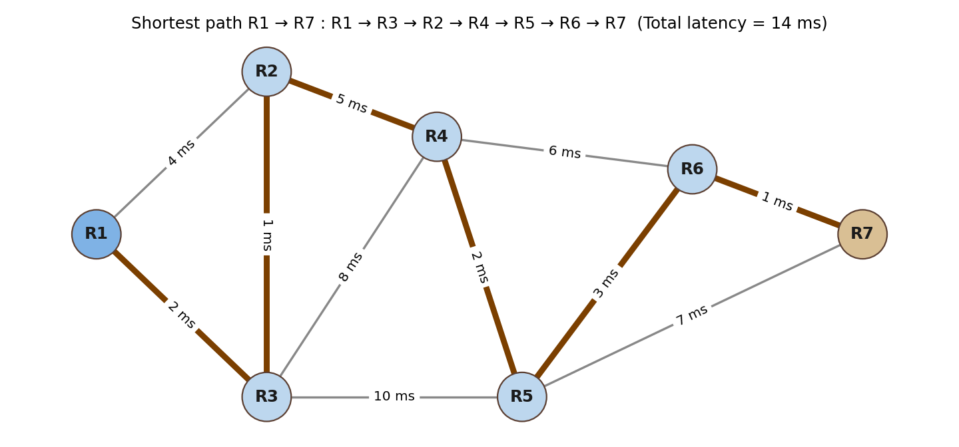
Fig. 5.1 Sample network graph and shortest path from R1 to R7 (latency as edge weights)
The distance table for this example is given below.
Router | Distance from R1 | Previous Router
R1 | 0 | ---
R2 | 3 | R3
R3 | 2 | R1
R4 | 8 | R2
R5 | 10 | R4
R6 | 13 | R5
R7 | 14 | R6

Shortest path: R1 -> R3 -> R2 -> R4 -> R5 -> R6 -> R7. Total latency: 14 ms.
5.5 Why Dijkstra's Algorithm is Correct
The correctness of the algorithm follows from the greedy-choice property. Suppose router u has the smallest distance among all routers that are not yet finalised. Any other path to u must leave the finalised set through some other unfinalised router x, whose distance is already at least that of u. Since latencies are non-negative, the rest of that path cannot reduce the total below the distance of u. Therefore the distance of u is already the shortest possible and can be finalised. Repeating this argument for every router proves that all final distances are optimal.
6. SYSTEM DESIGN
6.1 System Architecture
The application is organised into three parts. The data part stores the network in data.json. The logic part contains the Network class and Dijkstra's algorithm in dijkstra.py. The presentation part contains the command-line program (main.py), the graphical interface (gui.py) and the visualization (visualize.py). Keeping these parts separate makes the program easier to understand, test and extend.
Layer | Responsibility
Data layer | data.json holds routers, connections with latency values and routing requests. datademo.json holds a demonstration network.
Logic layer | dijkstra.py builds the adjacency list, runs Dijkstra's algorithm and returns the route and total latency.
Presentation layer | main.py, gui.py and visualize.py take input from the user and show the result as text and as a graph.
6.2 Flowchart
The flowchart below shows the working of the project. The network is loaded, the user selects the source and destination, Dijkstra's algorithm is executed, the route is reconstructed and the result is displayed on the graph.
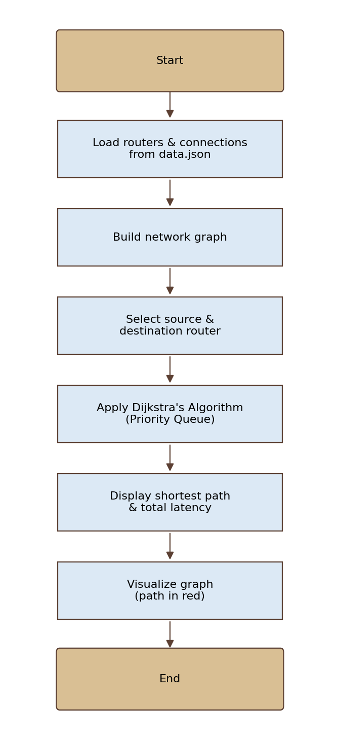
Fig. 6.1 Flowchart of the project
6.3 Graph Construction
Routers are considered as nodes and the latency of the connection between two routers is the edge weight. The connections are undirected, so a packet can travel in either direction with the same latency. The sample network of this project contains the following fourteen connections.
Router A | Router B | Latency
R1 | R3 | 2
R1 | R2 | 4
R3 | R2 | 1
R3 | R4 | 8
R3 | R5 | 10
R2 | R4 | 5
R2 | R8 | 12
R4 | R5 | 2
R4 | R6 | 3
R5 | R6 | 1
R5 | R7 | 6
R6 | R7 | 2
R6 | R8 | 7
R7 | R8 | 3

The attributes considered in the project are: routers as nodes, latency between routers as edge weights between the connected vertices, and the source and destination routers selected by the user.
7. DATA STRUCTURES AND MODULES
7.1 Input Data Format
The network is stored in JSON format. The file contains a list of routers, a list of connections and a list of routing requests. Sample data is shown below.
Router data
"routers": [
{ "id": "R1" },
{ "id": "R2" }
],

Connection data
"connections": [
{
"source": "R1",
"destination": "R2",
"latency": 4
}
],

7.2 Data Structures Used
Data Structure | Purpose
Adjacency list (dictionary) | Stores, for every router, the list of neighbouring routers with their latency. It needs O(V + E) space.
Distance dictionary | Stores the best known distance from the source to every router. Initially infinity for all routers except the source.
Previous dictionary | Stores the router from which each router was reached, used to rebuild the route.
Priority queue (min-heap) | Returns the router with the smallest distance in O(log V) time.
List of requests | Stores the predefined source and destination pairs shown to the user.
7.3 Project Modules
File | Description
dijkstra.py | Contains the Network class, graph loading and Dijkstra's algorithm.
main.py | Command-line entry point of the application.
gui.py | Tkinter window with drop-down lists for source and destination and the Find Shortest Path button.
visualize.py | Lists the routing requests, runs the algorithm for the chosen request and draws the graph using NetworkX and Matplotlib.
data.json | Network data: routers, connections and routing requests.
datademo.json | Demonstration data file.
README.md | Description of the project and instructions to run it.
8. IMPLEMENTATION
8.1 Loading the Network
The program begins by importing the required modules: json for reading the data file, sys for command-line handling, networkx and matplotlib.pyplot for the graph and the drawing, and the Network class from dijkstra.py. A function load_data(filename) opens the JSON file with UTF-8 encoding and returns its contents as a Python dictionary.
import json
import sys
import networkx as nx
import matplotlib.pyplot as plt

from dijkstra import Network

def load_data(filename):
with open(filename, "r", encoding="utf-8") as file:
return json.load(file)

8.2 Building the Graph
For every connection in the data file, the program adds an edge between the two routers in both directions with the given latency. This produces the adjacency list on which the algorithm works.
8.3 Running Dijkstra's Algorithm
The algorithm is called with the source and destination routers. A priority queue holds pairs of distance and router. At each step the pair with the smallest distance is removed; if the stored distance is older than the current best distance of that router, the pair is ignored. Otherwise the neighbours are relaxed. When the queue is empty, or when the destination is removed from it, the algorithm stops, and the previous dictionary is used to rebuild the route and to compute the total latency.
Algorithm in outline:
dist = {r: infinity for every router}; dist[source] = 0
heap = [(0, source)]
while heap is not empty:
d, u = pop smallest from heap
if d > dist[u]: continue
for v, w in neighbours of u:
if d + w < dist[v]:
dist[v] = d + w; previous[v] = u
push (dist[v], v) into heap
route = follow previous[] from destination to source, then reverse

8.4 Visualization
The visualization module draws all routers as circles and all connections as grey lines with the latency written on each line. The source router is coloured green, the destination router is coloured orange, and the edges of the shortest route are drawn in thick red lines. The title of the figure shows the source, the destination, the shortest route and the total latency, so that the picture explains itself.
8.5 Graphical User Interface
The graphical interface shows the heading INTERNET NETWORK ROUTING OPTIMIZER, a Network Information panel with the number of routers, the number of connections and the algorithm used, two drop-down lists for the source and destination routers, and the buttons Find Shortest Path and Reset. After the user presses Find Shortest Path, the result is shown as text and the topology graph is redrawn with the route highlighted.
9. USER INTERFACE AND SCREENSHOTS
9.1 Graphical Interface
The screenshot below shows the graphical interface of the project. The network information panel states that the network has 8 routers and 14 connections and that Dijkstra's algorithm is used. In this example, the source router R1 and the destination router R6 are selected. The result line reports that the shortest route is R1 -> R3 -> R2 -> R4 -> R6 with a total latency of 11 units, and the route is drawn in red on the network topology.
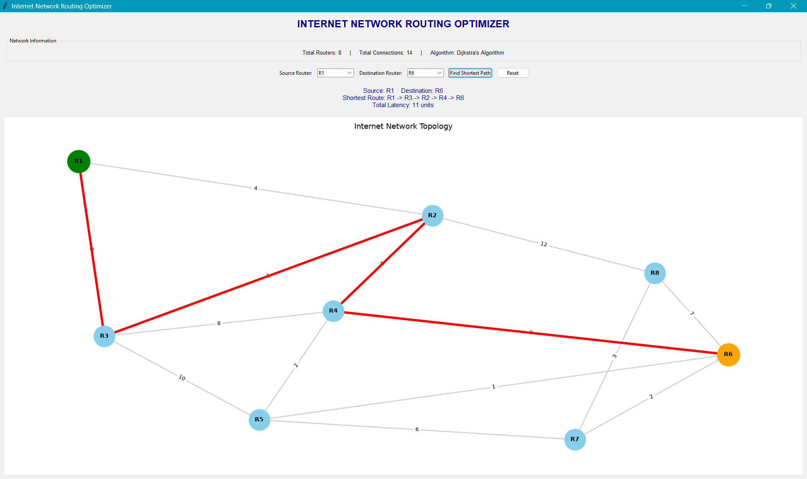
Fig. 9.1 Graphical interface of the Routing Optimizer (R1 to R6)
9.2 Command-Line Mode
In command-line mode the program lists the available routing requests and asks for a Request ID. The screenshot shows the program being run from the Visual Studio Code terminal. Five routing requests are listed: R1 to R8, R2 to R7, R3 to R6, R1 to R5 and R4 to R8. The user entered 3, and the program printed the routing result: source R3, destination R6, shortest route R3 -> R2 -> R4 -> R6 and total latency 9 units.
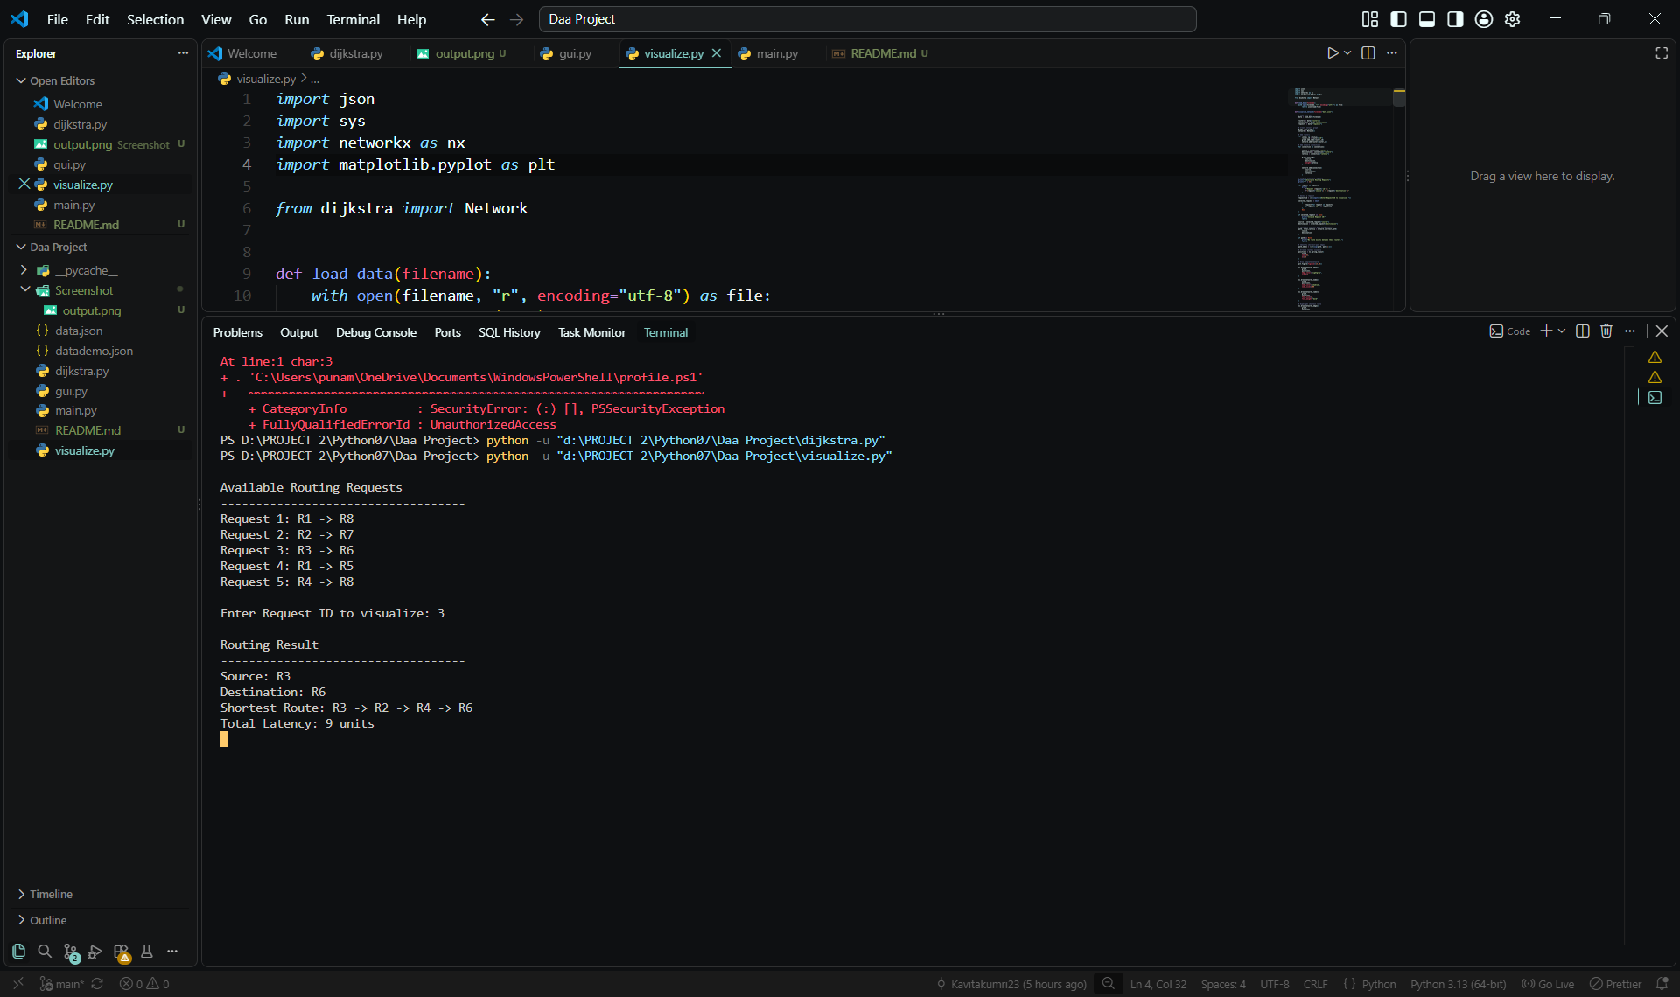
Fig. 9.2 Command-line mode: selecting routing request 3 (R3 to R6)
9.3 Route Visualization
After the result is printed, a Matplotlib window opens and shows the network graph. The title of the figure contains the source, destination, shortest route and total latency. The source router R3 is green, the destination router R6 is orange, and the edges R3-R2, R2-R4 and R4-R6 forming the shortest route are drawn in thick red lines with their latency values 1, 5 and 3.
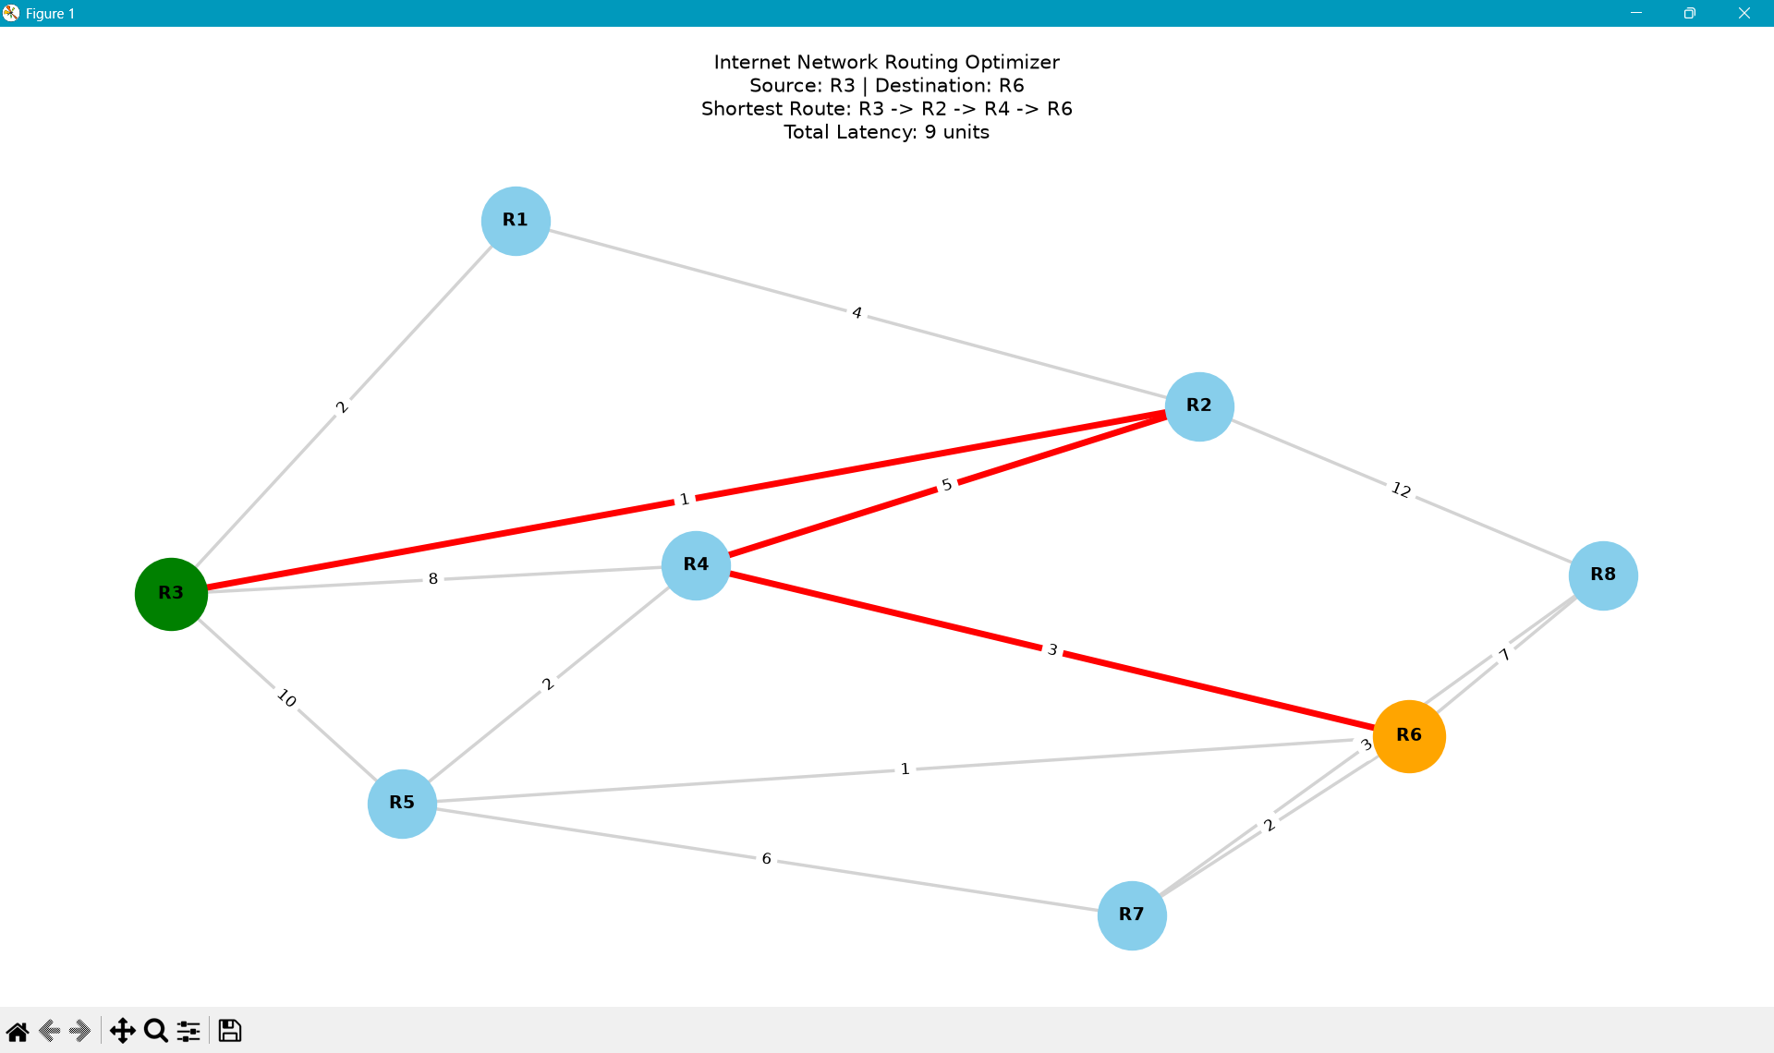
Fig. 9.3 Visualization of the route R3 to R6 (total latency 9 units)
9.4 Colour Code of the Graph
Element | Meaning
Green node | Source router selected by the user
Orange node | Destination router selected by the user
Light blue node | Other routers of the network
Grey line with number | Connection between two routers with its latency
Thick red line | Link that belongs to the shortest route
10. TESTING AND RESULTS
10.1 Result for the Request R3 to R6
The table below shows how the distances change during Dijkstra's algorithm when the source is R3. The routers are finalised in the order of their distance.
Step | Router picked | Distance | Distances updated
1 | R3 | 0 | R2 = 1, R1 = 2, R4 = 8, R5 = 10
2 | R2 | 1 | R4 = 6 (via R2), R8 = 13
3 | R1 | 2 | No improvement
4 | R4 | 6 | R5 = 8, R6 = 9
5 | R5 | 8 | R6 = 9 (equal), R7 = 14
6 | R6 | 9 | R7 = 11, R8 stays 13
7 | R7 | 11 | R8 stays 13
8 | R8 | 13 | Finished

The final distances from R3 are: R3 = 0, R2 = 1, R1 = 2, R4 = 6, R5 = 8, R6 = 9, R7 = 11 and R8 = 13. R6 can be reached with the same latency of 9 through R4 or through R5; the program reports the route R3 -> R2 -> R4 -> R6, which is the route shown in the screenshots.
10.2 Test Cases
No. | Source - Destination | Shortest Route | Total Latency | Result
1 | R1 - R6 | R1 -> R3 -> R2 -> R4 -> R6 | 11 units | Pass
2 | R3 - R6 | R3 -> R2 -> R4 -> R6 | 9 units | Pass
3 | R1 - R7 | R1 -> R3 -> R2 -> R4 -> R5 -> R6 -> R7 | 14 ms (sample graph of Fig. 5.1) | Pass
4 | R6 - R6 | R6 | 0 | Pass
5 | Invalid router name | Error message shown | - | Pass

Test case 3 refers to the sample graph used in the worked example of Chapter 5, and test case 5 checks that a router which is not in the network is rejected by the program.
10.3 Observations
- The route with the fewest links is not always the route with the least latency. For example, the direct link R3-R4 has latency 8, but the route R3 -> R2 -> R4 has a total latency of only 6.
- The direct link R3-R5 has latency 10, but R5 can be reached with latency 8 through R4.
- The result of the program matches the hand calculation of the distance table.
- The highlighted graph makes it easy to verify the answer visually.
11. COMPLEXITY ANALYSIS
11.1 Time Complexity
Let V be the number of routers and E the number of connections. Every router is extracted from the priority queue at most once in its final form, and every connection is relaxed at most twice (once for each direction). Each insertion or removal on a binary min-heap takes O(log V) time. Therefore the total time complexity of the algorithm using a priority queue (min-heap) is O((V + E) log V).
Implementation | Time Complexity
Array / simple list for minimum search | O(V^2)
Binary min-heap (used in this project) | O((V + E) log V)
Fibonacci heap | O(E + V log V)

For the sample network V = 8 and E = 14, so the number of operations is very small and the result is produced instantly.
11.2 Space Complexity
The adjacency list needs O(V + E) space. The distance dictionary, the previous dictionary and the priority queue need O(V) additional space, or O(E) in the worst case for the queue when duplicate entries are stored. The overall space complexity is O(V + E).
11.3 Comparison with Other Shortest Path Algorithms
Algorithm | Negative weights | Time | Use
Dijkstra | Not allowed | O((V+E) log V) | Single source, non-negative weights
Bellman-Ford | Allowed | O(V x E) | Single source, negative weights
Floyd-Warshall | Allowed (no negative cycle) | O(V^3) | All pairs of nodes
BFS | Not applicable | O(V + E) | Unweighted graphs only

Dijkstra's algorithm is the most suitable choice for this project because latency values are never negative and a single source is used in each request.
12. CONCLUSION AND FUTURE ENHANCEMENTS
12.1 Conclusion
Dijkstra's algorithm finds the shortest path between two nodes. In this project it was used to find the minimum-latency path between the selected source and destination routers. The distances to all routers are initialised to infinity, the source is set to 0, and the router with the minimum distance is repeatedly extracted from the priority queue while its neighbours are relaxed. The previous-router array is then used to reconstruct the route, which is displayed in the terminal and highlighted on the graph.
The sample results, such as 9 units for R3 to R6 and 11 units for R1 to R6, agree with the hand calculation. The project met all its objectives: it represents a network as a graph, reads the data from JSON, finds the best route, shows the result as text and as a picture, and provides a simple graphical interface. It also helped in understanding graphs, greedy algorithms, priority queues and complexity analysis.
12.2 Future Enhancements
- Allow the user to add, delete and edit routers and connections from the interface.
- Use live latency values measured with tools such as ping instead of fixed sample values.
- Show all equal-cost routes and the second-best route as an alternative.
- Animate the algorithm step by step to show how distances are updated.
- Add link failure simulation so that traffic is rerouted when a connection is removed.
- Compare Dijkstra's algorithm with A*, Bellman-Ford and Floyd-Warshall on the same network.
- Convert the application into a web application so that it can be used from a browser.
13. VIVA QUESTIONS AND ANSWERS
Q1. What is Dijkstra's algorithm?
Ans. It is a greedy algorithm that finds the shortest path from a source node to the other nodes of a weighted graph with non-negative edge weights.
Q2. Why are routers taken as nodes and latency as weights?
Ans. A network is naturally a graph: devices are vertices and links are edges. The latency of a link is the cost of using it, so minimising total weight gives the fastest route.
Q3. Why does Dijkstra's algorithm not work with negative weights?
Ans. Once a router is finalised, its distance is assumed to be optimal. A negative edge could later reduce that distance, which breaks the greedy-choice property.
Q4. What is relaxation?
Ans. Relaxation checks whether the path through router u gives a smaller distance to its neighbour v, and if so updates the distance of v and its previous router.
Q5. Why is a priority queue used?
Ans. It gives the unfinalised router with the smallest distance in O(log V) time instead of searching all routers in O(V) time.
Q6. What is the time complexity of the project?
Ans. O((V + E) log V) with a binary min-heap.
Q7. What is the space complexity?
Ans. O(V + E) for the graph, distance array, previous array and priority queue.
Q8. How is the route reconstructed?
Ans. By starting at the destination and following the previous[] array back to the source, then reversing the list.
Q9. What happens if there are two routes with equal latency?
Ans. The algorithm returns one of them, depending on the order of processing. For R3 to R6 there are two routes of latency 9, and the program reports R3 -> R2 -> R4 -> R6.
Q10. Is the shortest path always the one with the fewest hops?
Ans. No. The route with fewer links can have a higher total latency, as seen for R3 to R4, where the two-link route has latency 6 and the direct link has latency 8.
Q11. Which algorithm should be used if some weights are negative?
Ans. Bellman-Ford, which allows negative edges but has time complexity O(V x E).
Q12. Which library is used for drawing the graph?
Ans. NetworkX builds the graph and layout, and Matplotlib draws it.
Q13. Why is the data stored in a JSON file?
Ans. So that the network and the routing requests can be changed without modifying the program.
Q14. How does this relate to real Internet routing?
Ans. Protocols such as OSPF use Dijkstra's algorithm on a map of the network to compute the best routes.
Q15. What is a greedy algorithm?
Ans. An algorithm that makes the locally best choice at each step in the hope of reaching a globally optimal solution.
REFERENCES
- GeeksforGeeks, "Dijkstra's Shortest Path Algorithm - Greedy Algo-7", https://www.geeksforgeeks.org/dijkstras-shortest-path-algorithm-greedy-algo-7/
- T. H. Cormen, C. E. Leiserson, R. L. Rivest and C. Stein, Introduction to Algorithms, MIT Press.
- NetworkX documentation, https://networkx.org/documentation/stable/
- Matplotlib documentation, https://matplotlib.org/stable/
- Python documentation: heapq, json and tkinter modules, https://docs.python.org/3/
- Source code: https://github.com/Kavitakumri23/DAA-Project.git

